H.T No
Regulations:
A20

Sreenidhi Institute of Science and Technology
(An Autonomous Institution)
Code No:8CC07 Date: 12-Aug-2024 (AN)

B.Tech III-Year I- Semester External Examination, August-2024 (Supplementary)
IC APPLICATION (EEE and ECM)

Time: 3 Hours Max.Marks:70

Note: a) No additional answer sheets will be provided.
b) All sub-parts of a question must be answered at one place only, otherwise it will not be valued.
c) Missing data can be assumed suitably.

Bloom's Cognitive Levels of Learning (BCLL)

Remember | L1 | Apply | L3 | Evaluate | L5
Understand | L2 | Analyze | L4 | Create | L6

Part - A Max.Marks:20
Answer all QUESTIONS

 |  | BCLL | CO(s) | Marks
1 | Define input offset voltage and explain why it exists in all op-amps. | L1 | CO1 | [2M]
2 | Define stable and quasi stable state | L1 | CO2 | [2M]
3 | Draw the circuit diagram of Second order high pass filter. | L1 | CO3 | [2M]
4 | List different ADC and DACs. | L1 | CO4 | [2M]
5 | What is meant by Tri-state logic? | L1 | CO5 | [2M]
6 | How to interface the TTL logic gates to the CMOS logic? | L1 | CO6 | [2M]
7 | Outline the reasons why open loop is not preferred for linear applications. | L1 | CO1 | [2M]
8 | Distinguish successive approximation ADC with dual slope ADC. | L2 | CO4 | [2M]
9 | Paraphrase noise margin in IC logic family. | L1 | CO5 | [2M]
10 | Define slew rate. What causes it? | L1 | CO6 | [2M]
Part – B Max.Marks:50
ANSWER ANY FIVE QUESTIONS. EACH QUESTION CARRIES 10 MARKS.

 |  |  | BCLL | CO(s) | Marks
11. | a) | Summarize the difference between the inverting and non-inverting terminals. What do you mean by the term “virtual ground”? | L2 | CO1 | [5M]
 | b) | Compare the difference between DC and AC amplifiers, with respect to the op-amp parameters or DC and AC characteristics. | L5 | CO1 | [5M]
12. | a) | Design a Monostable multivibrator using 555 timer to produce a pulse width of 100 m sec. | L6 | CO2 | [5M]
 | b) | Draw and explain the operation of an op-amp as an differentiator. | L1 | CO2 | [5M]
13. | a) | Write the design steps for 1st order LPF | L1 | CO3 | [5M]
 | b) | For the circuit shown below Vref=2 V, +Vsat=+10V, -Vsat=-10V, R1=10K and R2=1K.(a) Determine VUTP and VLTP.(b) Let Vi be a triangular waveform with a zero average voltage ,a 10V peak amplitude and a 10mS time period. Sketch V0 versus time over two periods.  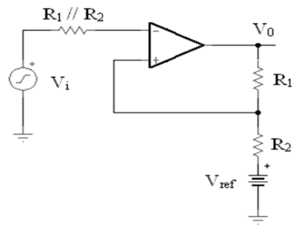  . | L5 | CO3 | [5M]
14. | a) | Analyze successive approximation A/D converter faster than dual-slope A/D converter? Explain. | L4 | CO4 | [5M]
 | b) | With the help of a neat circuit diagram and waveforms, explain the operation of a dual slope ADC. What are its special features? | L2 | CO4 | [5M]
15. | a) | Draw the schematic circuit of TTL active pull-up NAND gate and explain its operation with the help of Truth-Table. | L2 | CO5 | [5M]
 | b) | What is meant by Tri-static logic? Draw the circuit of Tri-state TTL logic and explain its functions. | L1 | CO5 | [5M]
16. | a) | - What are the advantages and disadvantages of CMOS over TTL gate?  - Which is the fastest saturated logic gate? and Why? | L1 | CO6 | [5M]
 | b) | Explain TTL to CMOS and CMOS to TTL interfacing. | L2 | CO6 | [5M]
17. | a) | List the all characteristics of an ideal op-amp | L1 | CO1 | [4M]
 | b) | For the circuit shown below, Compute the value of resistor Rf to obtain a gain of `5’? (Assume Ideal Op Amp).  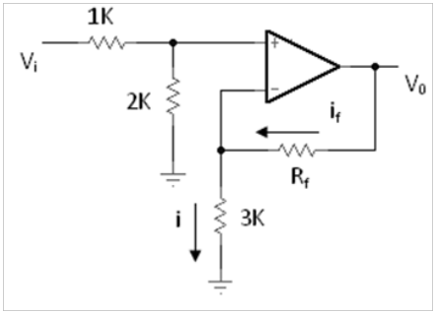 | L2 | CO2 | [3M]
 | c) | List various applications of IC 555 Timer | L1 | CO3 | [3M]
18. | a) | Illustrate the circuit of Weighted Resistor DAC and derive expression for output analog voltage Vo. | L4 | CO4 | [4M]
 | b) | Which is the fastest non-saturated logic gate? Draw the circuit and explain its functions | L1 | CO5 | [3M]
 | c) | Explain the operation of open drain output of CMOS? | L2 | CO6 | [3M]
-- 00 -- 00 –

